Cairo University  
Faculty of Computers and Artificial Intelligence

**CS251 - Software Engineering I**

Parking Garage System

Software Design

Team Names

April-2022

Contents

Instructions [To be removed] 3

Team 3

Document Purpose and Audience 3

System Models 3

I. Class diagrams 3

Important Algorithm 4

II. Sequence diagrams 5

Class - Sequence Usage Table 6

Ownership Report 6

Policy Regarding Plagiarism: 7

# Team

|  |  |  |  |
| --- | --- | --- | --- |
| **ID** | **Name** | **Email** | **Mobile** |
| 20200397 | Kareem Waleed Ali | karimw11@yahoo.com | 01023989953 |
| 20200254 | Sherif Ahmed Mohamed | 11410120200254@stud.cu.edu.eg | 01023955837 |
| 20200503 | Mahmoud Nader Ali | mahnader222@gmail.com | 01127264619 |
| 20200159 | Hussein Mohamed El-Morsy | Huessinessa855@gmail.com | 01158354262 |

# Document Purpose and Audience

# Document purpose is a way of communication with the project manager and developers that illustrates the flow of events in a simplified way to facilitate the code implementation for the developers

# The audience targeted are the project manager and developers.

# System Models

# I. Class diagrams

| **Class ID** | **Class Name** | **Description & Responsibility** |
| --- | --- | --- |
| CLASS_001 | Slot | It is an entity class that:   * carries the dimensions of the slot in the garage * holds the status of each slot * associated with the ”Garage” class to hold the data of each vehicle |
| CLASS_002 | Garage | It is the controller class which acts as the core of the parking system which is used for:   * parking-IN and parking-OUT functions * displaying available slots * connects with the other classes |
| CLASS_003 | Vehicle | It is responsible for:   * holding the data of each vehicle * stores the arrival and departure time of each vehicle |
| CLASS_004 | GUI Form | It is the boundary class that acts as the interface for inputting and outputting the items required for the application |

### Important Algorithm

* **Linear Search: This algorithm is used to loop in the array for the specified item. If the item not found , it return**
* **Best-Fit Approach: This algorithm is used to loop on the array and check for the condition which gets the minimum slot that fit the vehicle.**

## 

## II. Sequence diagrams

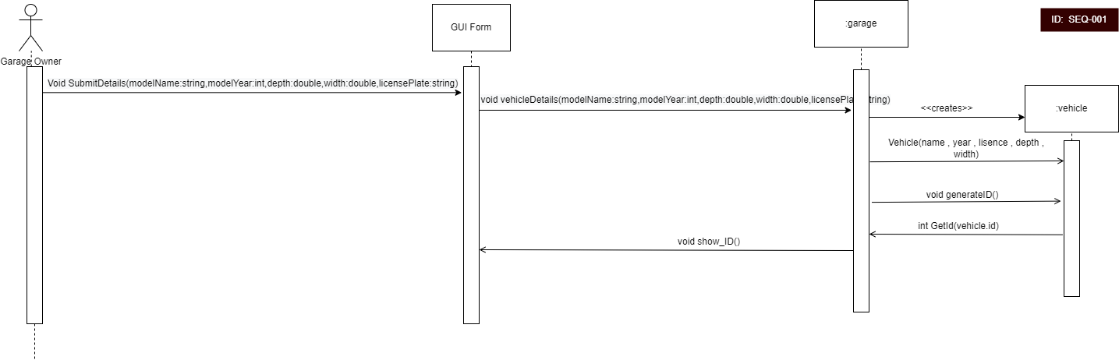

### 

### 

### 

### 

### 

### 

### 

### Class - Sequence Usage Table

| **Class Name** | **Sequence Diagrams** | **Overall used methods** |
| --- | --- | --- |
| GUI Form | SEQ-001 , SEQ-002 , SEQ-003 , SEQ-004 , SEQ-005 , SEQ-006 , SEQ-007 , SEQ-008 | displayInformation, chooseCash , chooseCreditCard , submitPark_OUT , chooseFawry , EnterCreditCard , EnterCreditCardNumber , EnterPassword , submitAmount , ConfirmPayment , SubmitID , getChoice , displayAvailableSlots , submitPark_IN , ShowTotalFees , ShowID , SubmitDetails |
| Vehicle | SEQ-001 , SEQ-002 , SEQ-008 | vehicle , generateID , getArrival , getDeparture , getWidth , getDepth |
| Garage | SEQ-001 , SEQ-002 , SEQ-003 , SEQ-004 , SEQ-005 , SEQ-006 , SEQ-007 , SEQ-008 | Best_Fit_Config , First_In_First_Served , park_IN , request_Avail_Slots , calculateTotalFees , vehicleDetails , getIncome , getNum , searchByID , getTime , displayIncome , displayNum , GetDepartureTime , SubmitChoice , getVehicleByID , CalculateTotalFees , getSlotByID |
| Slot | SEQ-002 , SEQ-004 | setDepth , setWidth , SetStatus , getVehicleByID |

# Ownership Report

|  |  |
| --- | --- |
| **Item** | **Owners** |
| Introduction | Sherif Hassan, Kareem Waleed Ali, Mahmoud Nader, Hussein Mohamed El-Morsy |
| Class diagram | Sherif Hassan, Kareem Waleed Ali, Mahmoud Nader, Hussein Mohamed El-Morsy |
| Algorithms | Sherif Hassan, Kareem Waleed Ali, Mahmoud Nader, Hussein Mohamed El-Morsy |
| SEQ 008, SEQ 001 | Hussein Mohamed El-Morsy |
| SEQ 004, SEQ 007, SEQ 006 | Mahmoud Nader |
| SEQ 002 | Sherif Hassan, Kareem Waleed Ali |
| SEQ 003 | Kareem Waleed Ali |
| SEQ 005 | Sherif Hassan |

# Policy Regarding Plagiarism:

1. تشجع الكلية على مناقشة الأفكار و تبادل المعلومات و مناقشات الطلاب حيث يعتبر هذا جوهريا لعملية تعليمية سليمة
2. ساعد زملاءك على قدر ما تستطيع و حل لهم مشاكلهم فى الكود و لكن تبادل الحلول غير مقبول و يعتبر غشا.
3. أى حل يتشابه مع أى حل آخر بدرجة تقطع بأنهما منقولان من نفس المصدر سيعتبر أن صاحبيهما قد قاما بالغش.
4. قد توجد على النت برامج مشابهة لما نكتبه هنا أى نسخ من على النت يعتبر غشا يحاسب عليه صاحبه.
5. إذا لم تكن متأكدا أن فعلا ما يعد غشا فلتسأل المعيد أو أستاذ المادة.
6. فى حالة ثبوت الغش سيأخذ الطالب سالب درجة المسألة ، و فى حالة تكرار الغش سيرسب الطالب فى المقرر.